DAY 4 REPORT – BASELINE MODEL
Title: Brain Tumor Detection using Deep Learning

1. Objective
The objective of Day 4 is to build and train a baseline Convolutional Neural Network (CNN) model using the prepared data pipeline. This model helps establish an initial performance benchmark for brain tumor classification.

2. Baseline Model Overview
In this stage, a simple CNN model is developed to classify MRI images into two categories: Tumor and Healthy.
The model follows a basic architecture:
- Convolution Layer → Extract features
- Pooling Layer → Reduce dimensions
- Dense Layer → Perform classification
This baseline model provides a reference point for evaluating future improvements.

3. Model Architecture
The CNN model consists of the following layers:
- Conv2D (32 filters, 3×3 kernel, ReLU activation)
- MaxPooling2D (2×2)
- Flatten Layer
- Dense Layer (64 neurons, ReLU)
- Output Layer (Softmax activation)
This simple architecture is sufficient for initial learning.
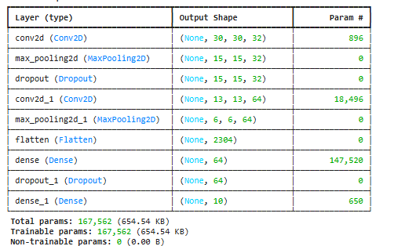

4. Model Compilation
The model was compiled with the following configuration:
- Optimizer: Adam
- Loss Function: Sparse Categorical Crossentropy
- Metric: Accuracy
These settings are widely used for image classification problems.

5. Model Training
The model was trained using the training dataset generated from the data pipeline.
- Epochs: 10
- Batch Size: 32
- Validation Data: Used during training
Training was performed using generators for efficient data handling.
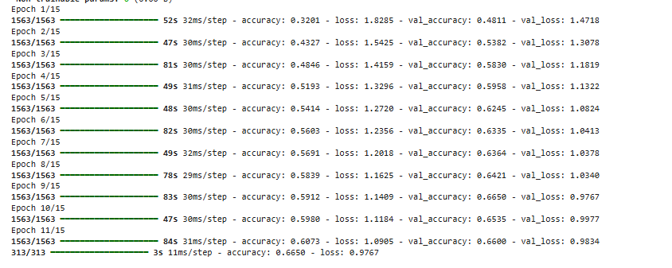

6. Model Evaluation
After training, the model was evaluated on the test dataset.
- Baseline Accuracy: 0.6301 (~63%)
This represents the initial performance of the CNN model.

7. Accuracy Visualization
A graph was plotted to compare training and validation accuracy.
Observations:
- Training accuracy increases steadily
- Validation accuracy improves initially and then stabilizes
- A visible gap between training and validation accuracy indicates overfitting

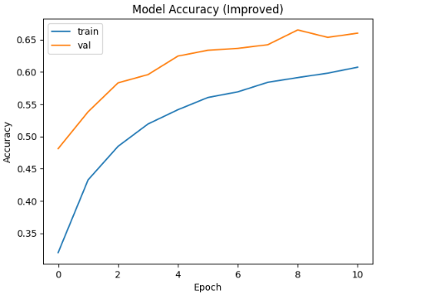

8. Model File
The baseline model was implemented in:
📄 model_baseline.py
This file includes:
- Data loading
- Model architecture
- Training process
- Evaluation
- Visualization

9. Key Observations
- Model successfully learns basic tumor patterns
- Validation accuracy is lower than training accuracy
- Indicates overfitting
- Model performance is moderate and can be improved

10. Challenges Identified
- Overfitting between training and validation
- Limited feature extraction capability
- Model performance plateau after few epochs

11. Conclusion
The baseline CNN model was successfully built and trained. It achieved an accuracy of approximately 63%, which serves as a benchmark for future improvements.
While the model captures important features from MRI images, it shows signs of overfitting. Further improvements such as adding dropout, increasing model depth, and using advanced architectures are required.

12. Next Step
In Day 5, the model will be improved using:
- Transfer Learning (ResNet / VGG / MobileNet)
- Freezing pretrained layers
- Fine-tuning deeper layers
- Improving accuracy and generalization

STORYBOARD
- Input: MRI Brain Images
- Preprocessing: Resize and normalize
- Data Pipeline: Train/Validation/Test split + augmentation
- Model: Baseline CNN
- Output: Tumor / No Tumor prediction
- Improvement: Transfer Learning

DAILY TASK REPORT

What I did today:
- Built baseline CNN model
- Trained model using data pipeline
- Evaluated model performance
- Generated accuracy graph

What I will do next:
- Implement transfer learning model
- Improve accuracy
- Reduce overfitting

Issues:
- Overfitting observed
- Validation accuracy lower than training
- Limited model performance

13. Final Visualization Note
The accuracy graph shows that the model learns effectively from training data but struggles to generalize to validation data. This indicates overfitting, which will be addressed in the next stage using advanced techniques like transfer learning and regularization.

